MedGuideAI
Prescription OCR & Medicine Reminder System
AIBOTS-2026 Hackathon
CareCircuit | KL University, Hyderabad
Electronics and Communication Engineering

Team
Team member | Student ID
Manogna | 2510040069
Shruthi Keerthi | 2510040009
D. Spandana | 2510040098
D.Nithya Sree | 2510040106

Executive summary
MedGuideAI progressed from a broad accessible reader and smart medicine-box proposal to a focused web baseline. The baseline accepts a prescription image, uses Tesseract OCR through pytesseract, presents raw text for human correction, and stores user-confirmed reminders in SQLite. OCR is an aid, not medical truth: users must verify details before saving. Available code shows additional TTS and ESP32 paths, but their timing relative to the review presentations is unknown.

Objectives
- Read suitable printed prescription images into editable text.
- Keep human verification between OCR and reminder creation.
- Organize user-confirmed reminder details and due times.

Problem definition
Reading small print, low-contrast text, handwriting, and medical terminology can make prescription transcription difficult. Manual reminder setup adds a second opportunity for omissions. OCR can reduce retyping for suitable printed text, while a reminder list can make user-entered plans visible. Neither replaces source verification or professional advice.
Requirement | Essential expectation
Functional | Upload supported image; run OCR; display editable text; allow manual correction; save user-confirmed medicine details; create and list reminders; show due/acknowledged state.
Safety | Do not guess uncertain names, interpret unverified dosage, diagnose, prescribe, or claim clinical accuracy.
Privacy | Minimize health data, delete temporary images after OCR, use fictional demo data, and avoid exposing the prototype publicly.
Reliability | Validate type and size; show errors for missing Tesseract, empty OCR, invalid time, or storage failure.
Accessibility | Use readable controls and provide optional speech/read-back where supported.

Constraints
OCR quality depends on image quality and Tesseract configuration. Browser notifications depend on permission, secure-context support, and browser behavior. ESP32 integration adds network, power, wiring, and authentication dependencies.

Review 1: initial proposed design
The initial vision joins accessible prescription reading with reminders. A user provides an image; OCR returns text for voice guidance and dashboard review. Confirmed reminder information is planned to drive an ESP32 medicine box. The proposal names an OLED display, buzzer, and acknowledgement button. These are design elements from the request summary, not proof that every component was demonstrated.
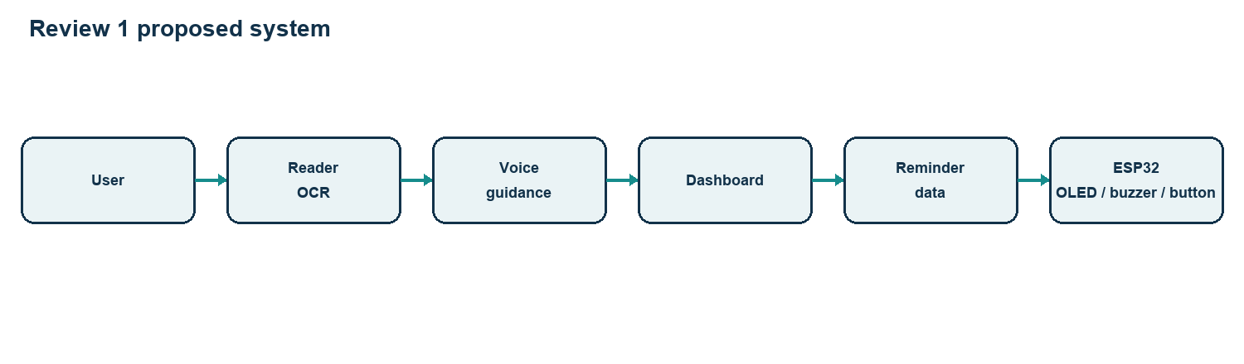
Review 1 proposed architecture
Component | Purpose | Evidence status
Accessible reader + OCR | Convert prescription image into text for review. | Proposed in Review 1; source snapshot also contains OCR code.
Voice guidance | Read recognized or verified text aloud. | Proposed; browser speech synthesis appears in the available source snapshot.
Dashboard | Review details and organize reminders. | Broad proposal; web UI exists in the source snapshot.
ESP32 box | Physical due-time alert and acknowledgement. | Proposed; firmware snapshot includes LEDs, buzzer, button; OLED not found.

Review 2: refined web baseline
The Review 2 description focuses on a smaller, testable application: browser upload, Flask request handling, Tesseract through pytesseract, extracted-text presentation, user correction, SQLite reminder storage, browser notifications, validation, error handling, and testing strategy.
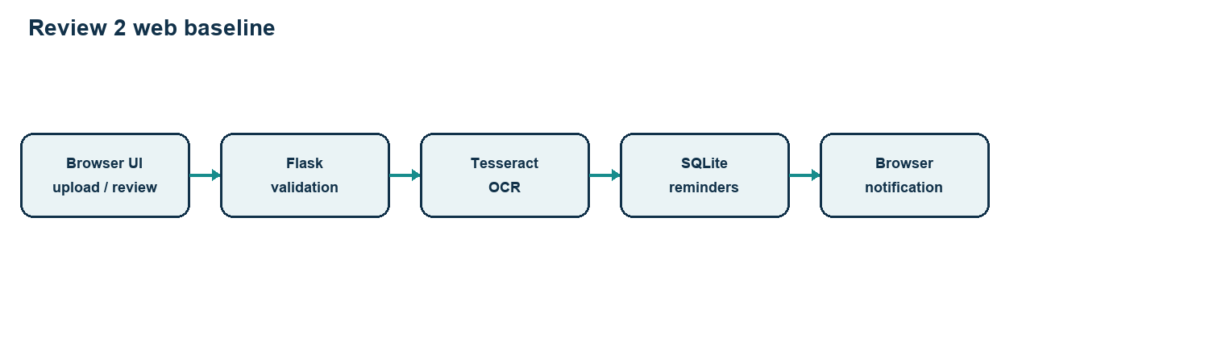
Review 2 baseline architecture
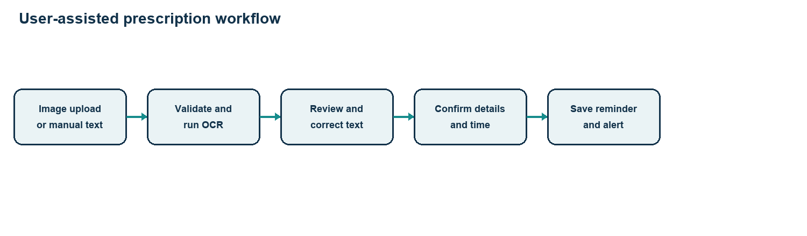
End-to-end workflow
Flow: select/upload image (or enter text manually) → validate file → run OCR → inspect and correct text → explicitly confirm medicine details → choose reminder time → save and display reminder. Browser alerts are permission- and platform-dependent.

Review evolution and implementation evidence
Area | Review 1 vision | Review 2 baseline | Inspected source snapshot
Scope | Accessible reader + hardware system. | Focused web workflow. | Web app plus optional TTS/device code; chronology vs reviews unknown.
OCR | Part of reader. | Tesseract via pytesseract. | Pillow grayscale/contrast preprocessing and raw-text response.
Verification | Voice/dashboard access. | User review central. | Verified flag required before saving medicine details.
Reminders | Dashboard drives device. | SQLite reminder creation/management. | Create/list/acknowledge/test; no delete route found.
Alerts | ESP32 buzzer and OLED. | Browser notifications. | Test notification code present; scheduled closed-page delivery not established.
Data handling | Risks to manage. | Validation and testing emphasized. | 8 MB limit and temporary image cleanup in upload route.

Architecture boundary
The available source snapshot is an earlier project folder; its chronology relative to the two review presentations is not established. The Review 2 architecture diagram reflects the review description. Optional device and speech code in the snapshot should not be scored as Review 2 functionality without dated evidence.

OCR, data handling, and safety
OCR converts image pixels to characters. Tesseract is an existing OCR engine; pytesseract is its Python interface. The available OCR module converts images to grayscale, increases contrast, and requests text from Tesseract. This is not a separately trained MedGuideAI model. Blur, skew, low resolution, handwriting, abbreviations, and medical vocabulary can cause substitutions or omissions.

Human verification and privacy
Every extracted medicine name, instruction, and time must be checked against the original prescription before saving. Unclear details must not be guessed. The inspected upload route removes temporary image files after processing. The local SQLite database has no evidenced account isolation; use fictional data and restrict access. Acknowledgement records an alert response, not medication ingestion.
Test case | Expected behavior
Clear / blurred / rotated / handwritten image | Show raw output; make poor recognition apparent; allow correction; never infer fields.
Empty / invalid / oversized upload | Reject with clear message; do not retain unwanted image.
No OCR text / missing engine | Show failure; keep manual entry available.
Create / list / delete reminder | Verify persistence and state; deletion remains a gap in inspected code.
Notification permission granted / denied | Record observed behavior; in-app reminder remains usable.
All test outcomes remain Not Tested; no accuracy percentage or demonstration result is claimed.

Limitations and next steps
Confirmed evidence gaps: original review files and reviewer feedback were unavailable; no executed test logs, screenshots, OCR metrics, or usability study were available; reminder deletion and OLED code were not found in the inspected snapshot. Anticipated risks include handwriting recognition, dependency configuration, time-zone handling, notification permissions, Wi-Fi, wiring, and privacy controls.
Priority | Next work
1 | Reconcile this report against both presentations; add dated review evidence.
2 | Run fictional-image OCR and reminder tests; record actual result, status, and evidence.
3 | Complete reminder lifecycle and notification behavior; evaluate accessibility.
4 | Only then extend hardware/OLED, privacy controls, and structured extraction.

Conclusion
MedGuideAI has a clear progression from a broad accessible reader and smart box proposal to a smaller web baseline. Its safest role is transcription and reminder organization with explicit human review. Available source code supports some concrete paths, but the review chronology and test outcomes remain unverified.

Future scope
Future improvements include testing OCR with a wider range of clear printed prescriptions, improving reminder management (including editing and deletion), strengthening privacy and access controls, and validating notification behavior across supported browsers. Hardware alerts and OLED display integration should be added only after the web workflow is tested reliably.

Key takeaway
MedGuideAI is designed to reduce manual prescription retyping and help users organize reminders. OCR output must always be checked against the original prescription; the system does not diagnose, prescribe, or replace advice from a qualified healthcare professional.

References
Tesseract OCR User Manual: https://tesseract-ocr.github.io/tessdoc/
Flask: Uploading Files: https://flask.palletsprojects.com/en/stable/patterns/fileuploads/
MDN: Notifications API: https://developer.mozilla.org/en-US/docs/Web/API/Notifications_API
Espressif ESP32 Getting Started: https://docs.espressif.com/projects/esp-idf/en/latest/esp32/get-started/

